**19. Word Sense Disambiguation Using the Lesk Algorithm**

**Aim:**  
To perform word sense disambiguation using the Lesk algorithm.

**Algorithm:**

1. Import Lesk from NLTK.
2. Provide a sentence with an ambiguous word.
3. Use the Lesk algorithm to determine the most suitable sense.

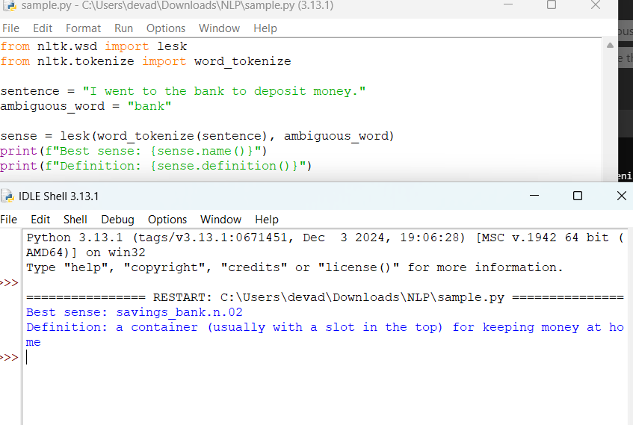

**Result:**  
The Lesk algorithm determines the correct sense of the ambiguous word "bank."